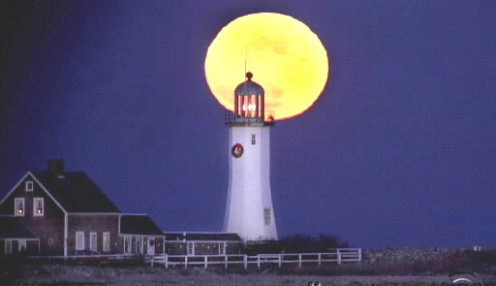



7:00 Open
Call to Order
7:30 Citizen Comments
7:35 Historical Commission - Sergeant Samuel Stetson House
Approval of Minutes

Appointments
- 2011-2012 Election Workers

Old Business

New Business

Road Openings
- Curtis Farm Road

Upcoming Meetings
Announcements
Adjournment
Executive Session

